Installation Instructions for Yielder

1. Register with Github/ sign in to Github <https://github.com/login> SuzanneMcC
2. Install Github on both the EOL, SOL Start of Line and graph display PCs.
3. Install TeamView on all machines and send the Passwords and usernames to MCR Agri analytics
4. On Github cloneOn GitHub, navigate to the main page of the repository.

Clone or download buttonUnder the repository name, click **Clone or download**.

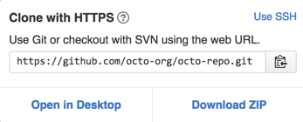In the Clone with HTTPs section, click  to copy the clone URL for the repository.

Open Git Bash.

Change the current working directory to the location where you want the cloned directory to be made.

Type git clone, and then paste the URL you copied in Step 2.

git clone https://github.com/*YOUR-USERNAME*/*YOUR-REPOSITORY*

Press **Enter**. Your local clone will be created.

git clone https://github.com/*YOUR-USERNAME*/*YOUR-REPOSITORY*

Cloning into `Spoon-Knife`...

remote: Counting objects: 10, done.

remote: Compressing objects: 100% (8/8), done.

remove: Total 10 (delta 1), reused 10 (delta 1)

Unpacking objects: 100% (10/10), done.

1. Push the following repository on
   1. Git bash from directory (right click)
   2. git add .
   3. git commit -m "First commit"
   4. git push

Check config files.